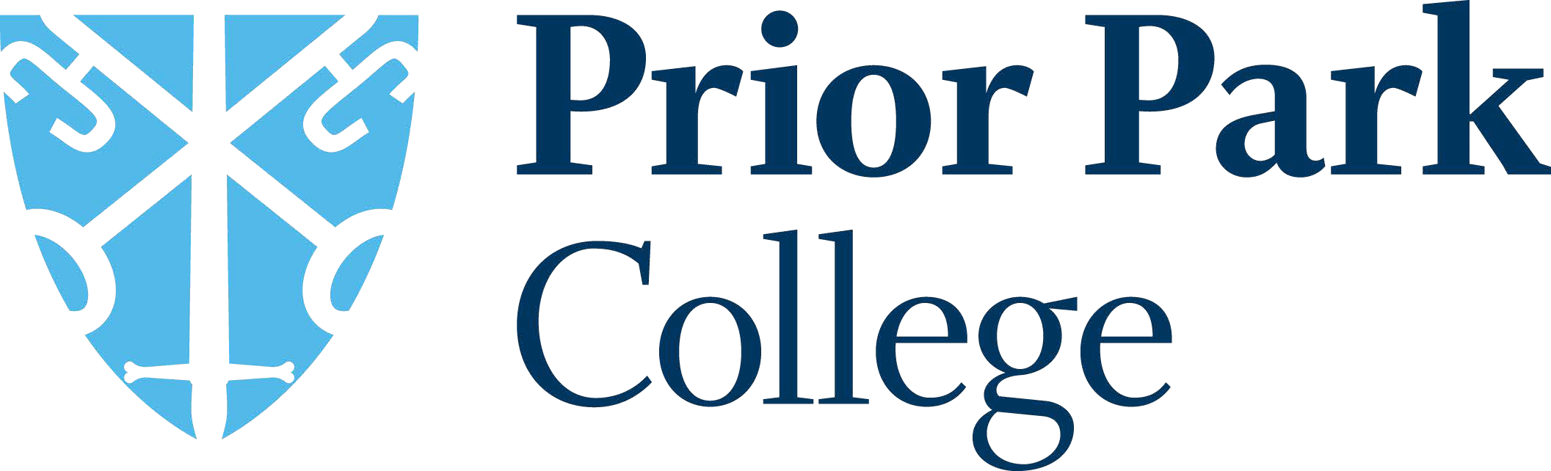

Prior Park College is part of Prior Park Educational Trust.

Mission Statement:

To steward a thriving family of communities with love for the young people they serve at their heart. Communities which cultivate creativity, foster integrity, and transform lives.

The mission statement is underpinned by our values:

Curiosity Generosity Courage

Prior Park College, a Christian school in the Catholic tradition, is a co-educational, day and boarding, senior school set in a breath-taking location, overlooking the UNESCO World Heritage City of Bath.

[Prior Park College | An Outstanding, Independent School in Bath](https://www.priorparkcollege.com/)

The College educates around 600 students from aged 11 to 18. We have up to 450 day pupils travelling to the school from within Bath and further afield across nearby counties every day with up to 150 full, weekly and flexi boarders from 20+ countries housed within two boarding houses as their term-time homes.

[Our Values and Vision | Prior Park College](https://www.priorparkcollege.com/welcome/our-values-and-vision)

The school's approach is simple:

*We value each individual and focus our attention on developing their unique talents to ensure an education of the whole person*.